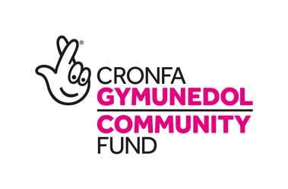

25 April 2025

Funding granted for new outdoor health service for the people of the Dyfi Valley.

‘Awyr Iach’, a new outdoor health service that will enable the people living in the Dyfi Valley in Mid Wales to access outdoor activities in nature to boost their health and wellbeing, has been granted National Lottery Community funding. It will be a free service available through the new Bro Ddyfi Community hospital.

The rural Dyfi Valley is full of rich environmental and outdoor resources, with the Biosffer Dyfi given UNESCO status in 2009. The Awyr Iach service will help connect local people with this rich local landscape to improve their health and wellbeing.

Awyr Iach meaning ‘Fresh Air’ in Welsh was inspired by the area itself and the original Machynlleth hospital, where many TB patients were provided with ‘fresh air’ treatments to improve their conditions.

Local resident Kate Jones said; ‘I have lived in Bro Ddyfi for 52 years, 27 of those working at the old chest hospital as a Care Assistant. I have found that being able to take part in outdoor health activities has been extremely beneficial for my wellbeing, improving my mobility and connecting me with local people and nature’.

As part of the services’ development, 445 local adults and young people took part in a survey which demonstrated the need for this new outdoor health service. 80% of those surveyed said that they wanted a nature on prescription service to complement the Hospital’s clinical care. 43% said they suffered from depression and anxiety and 33% said they suffered from mobility issues and joint pain. 98% said that nature activities could help improve these issues. Studies have shown that nature can lower stress hormones like cortisol, with two hours a week in nature significantly boosting health and well-being.

The Awyr Iach service will offer free year-long professionally led activities in nature for all ages, including woodland skills, cooking and foraging, walking, mindfulness and crafts. They will take place in the Hospital green spaces and in Machynlleth, as well as in two purpose built ‘Woodland Wellbeing Hubs’. A new electric community people carrier managed by local company TrydaNi will help people access these services.

Locals can sign up online or in person through an Outdoor Health Engagement Officer at the Hospital or their GP.

A Powys Teaching Health Board spokesperson said – ‘We are thrilled to take part in Awyr Iach, bringing together the strengths and expertise of Powys Teaching Health Board, Primary Care Centre, PAVO and local organisations for the first time as one outdoor health service complementary to clinical care’.

With almost 20% of those surveyed stating they would like to volunteer to help deliver the service, Awyr Iach will also offer opportunities to volunteer in conservation, gardening and walking.

Awyr Iach will be led by Coed Lleol – Small Woods, in partnership with Biosffer Dyfi and TrydaNi and funded by the National Lottery Community Fund to run over the next three years.

For more information or to arrange interviews please contact rosiestrang@smallwoods.org.uk, 07966071073

- ENDS –

