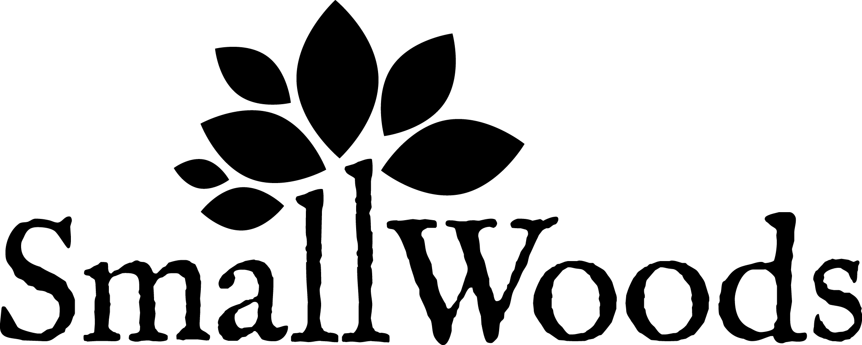

Annual General Meeting 2021
Report and Accounts for the year ended 31st March 2021

NOTICE IS HEREBY GIVEN
that the 21st Annual General Meeting of the Small Woods Association will be held online via Zoom for the following purposes:

Resolutions
1. To receive and adopt the financial statements of the company for the year ending 31st
March 2021 and the reports of the Directors and the Auditors thereon.
2. To re-elect three Board members: John Blessington, Phil Burton and Peter Watson.
3. To reappoint James, Holyoak and Parker, Chartered Accountants of Shrewsbury, as
Auditors and to authorise the Directors to set their remuneration.

BY ORDER OF THE BOARD
Chris Duncan, Company Secretary, 18th June 2021

SWA IS A REGISTERED CHARITY NO. 1081874, AND A CHARITABLE COMPANY LIMITED BY GUARANTEE NO. 3919849.
REGISTERED IN ENGLAND AND WALES. REGISTERED OFFICE: ‐ Green Wood Centre, Station Rd, Coalbrookdale, Telford, TF8 7DR. Tel: 01952 432769
The final accounts will be presented for approval by the directors at the Board meeting of 17th September 2021 for ratification by members at the AGM. Copies will be available for the AGM, or may be downloaded from www.smallwoods.org.uk, or a copy may be obtained from the main office on 01952 432769

AGENDA of the 21st Annual General Meeting of the Small Woods Association

1. To read the Notice Convening the Meeting

2. Apologies

3. Minutes of last year’s AGM and Chairman’s Report

4. Treasurer’s Report

5. To vote on resolutions:
- To adopt the financial statement for the year ending 31st March 2021
- To re-elect three board members: John Blessington, Phil Burton and Peter Watson.
- To re‐appoint James, Holyoak and Parker, Chartered Accountants of Shrewsbury, as Auditors and to authorise the Directors to set their remuneration

6. Any other relevant business (Company Secretary must be notified of the content in writing by 10th September 2021)

Under the ‘Memorandum & Articles of Association’, trustees who have been in office for three years are required to stand down and seek re‐election.

PROXY VOTING FORM FOR THOSE NOT ATTENDING AGM

I/We .........................................................................................................................................
Address/Postcode .....................................................................................................................
.............................................................................................................................................
being member/s of the above company, hereby appoint : ...................................................
Address/postcode ................................................................................................................
or failing him/her the chair of the meeting as my/our Proxy to vote on my-our behalf at the Annual General Meeting of the Company to be held online on 2nd October 2021 and at any adjournment thereof.
Signed ................................................................................ Date .......................................

RESOLUTIONS
- To adopt the Annual Report and Accounts for For □ Against □
the year ending 31st March 2021

- To re-elect Board members:
John Blessington For □ Against □
Phil Burton For □ Against □
Peter Watson For □ Against □
- To reappoint James, Holyoak and Parker as
Auditors to the Company and to authorise the
Directors to fix their remuneration For □ Against □

Please return the above form before 23rd September 2021 to:
Small Woods Association, Freepost RRBX-HCGE-ECLZ, Coalbrookdale, TF8 7DR
or by email to office@smallwoods.org.uk

